# Exercise – 3 : Assertions in JUnit

You need to use different assertions in JUnit to validate your test results.

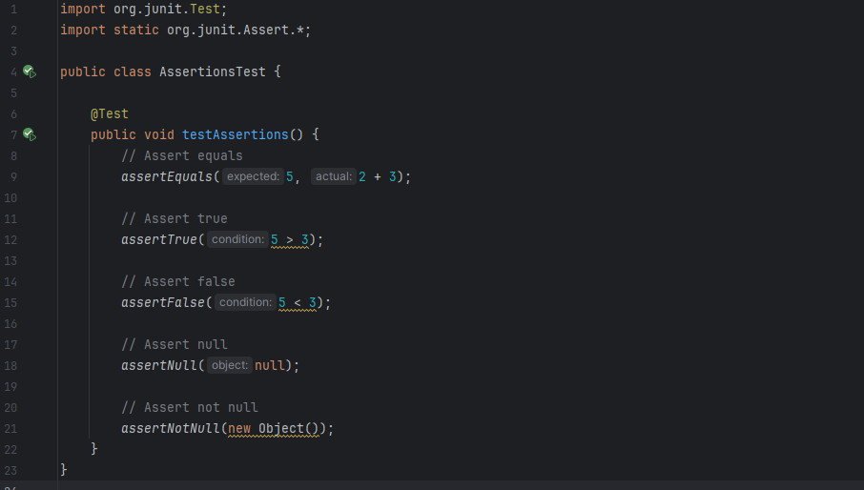

Output:

